Marketing Opportunity
EXPRESSION OF INTEREST
The aim of the WPPA is to rebuild a Pier in Withernsea, at the Pier Towers. This will be undertaken in distinct, separate stages, with the First Stage being a viewing Platform, an extension of the Promenade, accessed through Pier Towers, over the beach, extending to the end of the steps. We currently have Planning applied for, a Marine Licence to enable building, and imminent considerations for funding for the construction of the Viewing platform
As part of our plans going forward, we are looking to make Commercial pitches/stalls available to rent on the viewing platform, as well as the two rooms in Pier Towers, which we shall take over from the Council. Opportunities will be available to local businesses to take advantage of the expected visitor numbers coming to see the Viewing Platform
We are therefore asking for interested parties to advise if they would wish to be considered for stalls/rooms, size of stall, months preferred, etc.
If interested, please complete the attached form and return it to us. This places you under no obligation at this point, but will enable us to plan seating on and around the Viewing Platform
Thanking you in anticipation

K T Watson
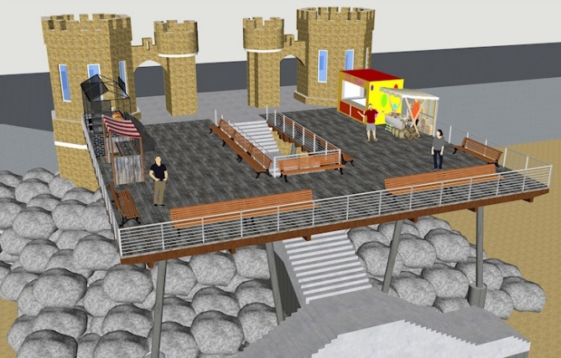
Secretary WPPA

Artist Impression of Viewing Platform
Expression of Interest
This is to register interest in being considered for the use of pitches/stalls which may become available on the First Stage of the Withernsea Pier, the Viewing Platform.
COMPANY / BUSINESS NAME
……………………………………………………………………………………………………………………………………………
ADDRESS
……………………………………………………………………………………………………………………………………………
CONTACT NAME
……………………………………………………………………………………………………………………………………………
TELEPHONE AND E-MAIL ADDRESS
……………………………………………………………………………………………………………………………………………
MERCHANDISE/PRODUCTS
……………………………………………………………………………………………………………………………………………
SIZE OF STALL
……………………………………………………………………………………………………………………………………………
Months preferred to trade on the platform or from the towers
……………………………………………………………………………………………………………………………………………
Return completed form to the WPPA at the above address, or by email to pier@withernsea1.co.uk

Please note – this is an expression of interest only, and places neither party under obligation

